White Paper
Demonstration of the Seldon Waterbox™ During Talisman Sabre’11

Michael J. Wagner

711 Human Performance Wing
Human Effectiveness Directorate
Biosciences and Performance Division, Applied Biotechnology Branch
2729 R. Street, Area B
Wright-Patterson AFB, OH 45433
michael.wagner2@wpafb.af.mil

- Objective
The primary objective of our proposed effort would be the demonstration of novel, light weight water purification products including a portable, small-unit based system (Waterbox™) and an individual person hydration device (Waterstick™). The goal will be to demonstrate that these technologies can provide USEPA compliant drinking water from any fresh (not salt or brackish) water source. Both products are simple plug-and-use devices that do not require contact time, high pressure, chemicals, heat, UV light or extensive training to operate.

2. Demonstration Products for Talisman Sabre’11
Seldon Technologies, Inc. has developed and introduced Nanomesh™ media, a patented filtration technology based on combining paper technology and functionalized carbon nanotubes (CNT). Addition of CNTs to filter media offers outstanding material properties including an extreme increase in total surface area, increased strength, , high electrical conductivity and rapid heat transport in a lightweight material. The Nanomesh™ product is created using a paper application, scalable reel to reel process. This media provides water purification technology with superior final contamination removal and enhanced performance, especially in a remote drinking water need application such as those encountered by military personnel. Nanomesh™ filter media is capable of removal of bacteria, virus, Cryptosporidium and Giardia to USEPA Drinking Water Standards.
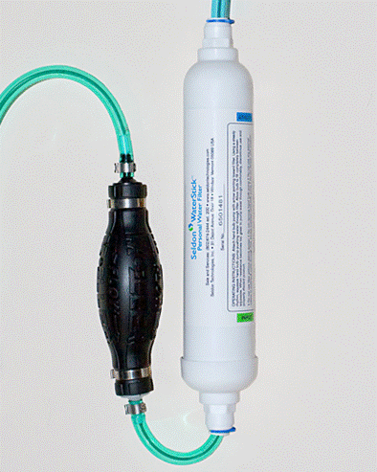
Seldon has developed three families of water filtration products utilizing its Nanomesh™ media: portable personal water filters (Waterstick™), mobile point of use water systems for small groups (Waterbox™), and fixed point of use filter systems for residential and commercial applications (Watertap™). Of these three, the Waterbox™ and Waterstick™ are two products that can be demonstrated for use in austere military conditions.

The Seldon Waterstick™ (pictured at right) is a personal water filter that is capable of producing 70 gallons of drinking water at about 6 oz per minute, depending on input water quality. This compact two-stage design allows for a variety of applications for stand-alone use including integration with a hydration pack or for gravity fed filteration. The Waterstick™ also features a bite valve or hand pump for point-of-use water filtration.

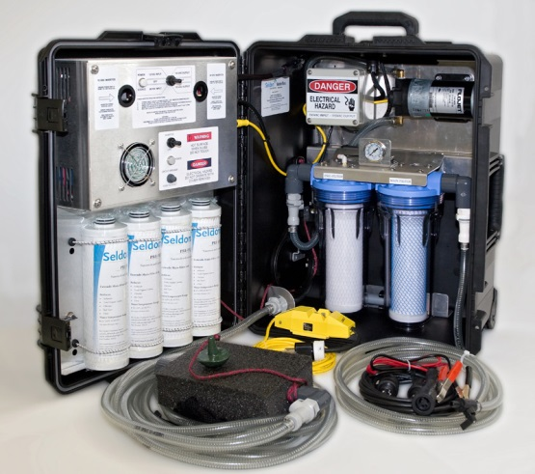
The Seldon Waterbox™ is a mobile, self-contained filtration system designed to support a small squad of ground personnel. The two-filter design is capable of purifying up to 1200 gallons of water at about half a gallon per minute, depending on input water quality. This system is capable of operating on a variety of power source choices that are available including 12 V DC, 24 V DC, 115 AC, 230 AC, or manual pump when battery and electricity use is impossible. Designed for quick set up and simplicity of use, the Waterbox™ can provide rehydrating water without waiting time.

3. Sponsorship
This project is sponsored by INDOPACOM J45X and NSWC PHD. It has been funded yearly since 2005 through a series of Congressional Add sponsorship. Additional FY10 funding (associated with air and water/fluid filtering) is currently pending award. Funding for FY11 is not guaranteed to AFRL and/or Seldon due to unknown budget decisions associated Congressional earmarks.

4. Logistics
4.1 Deployment
Deployment of both the Waterbox™ and Waterstick™ are dependent on the quantity of devices needed for Talisman Sabre ’11. Each Waterbox™ weighs 54 lbs and occupies an estimated 4 cubic feet. A single Waterbox™ can be substituted for a piece of luggage for an individual traveler. If multiple systems are desired for demonstration, up to four systems can be deployed weighing 216 lbs and occupying slightly more than 16 cubic feet. Shipping of these systems requires minimal effort, so it should not impose any burden on embarkation. The Waterstick™ weighs approximately 1.1 lbs wet and occupies negligible space. At the conclusion of the exercise, the equipment would be returned to the contractor’s facility

4.2 Experiment Implementation
The field team to be deployed to Talisman Sabre’11 will consist of 1-2 scientists. Requirements for the Waterbox™ are: a priming height no greater than 14 feet high, electrical requirements listed above, a fresh (not salt or brackish) water source, and a reservoir to contain the product water (i.e. tank or water bottles).

